10/03/2024
Section 3: Installation & Setup
https://www.canva.com/design/DAEXMu7dx04/YOhzvUC8w3J43Er_njvMnQ/view
https://www.gitkraken.com/download/windows64
https://git-scm.com/download/win
https://git-scm.com/downloads/guis
Lesson 14
Windows Git Installation
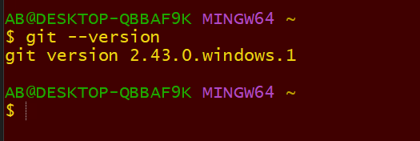
Lesson 16
Configuring Your Git Name & Email
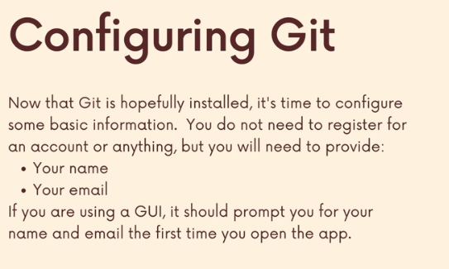
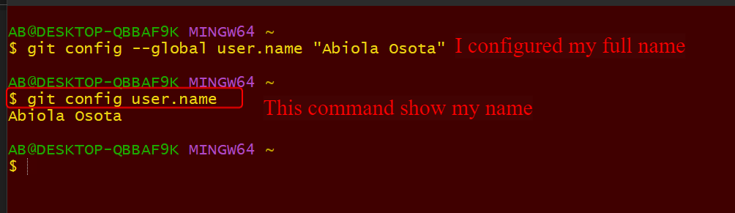
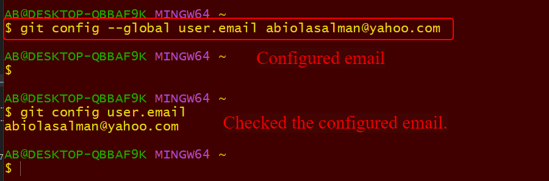
Lesson 17
Installing GitKraken (Our GUI)
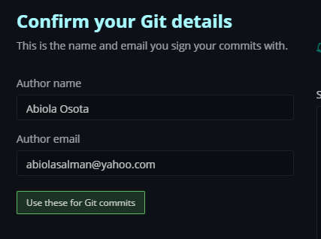
Lesson 18, 19, 20 21 are for Linux Crash course.
I don’t need those courses will forward.
